Multiple choice section

Question 1 [7.1]

The number missing from the equation 12 × 4 = 50 – __ is:

A 4 B 48 C 98 D 2

Question 2 [7.3]

The expression missing from the box below is:

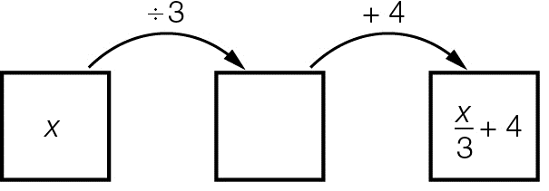

A x + 3 B 3x C  D 4x

Question 3 [7.4]

To balance the equation , the expression  must equal:

A 12 B 3 C 6 D 9

Question 4 [7.2]

Two times a number plus seven is equal to twenty one is written as:

A 2n + 7 = 21 B 2 + n + 7 = 21 C  + 7 = 21 D 2n – 7 = 21

Question 5 [7.1]

The underlined number is incorrect in the equation 3 + 6 = 10. The number should be:

A 5 B 6 C 7 D 8

Question 6 [7.4]

 is equivalent to:

A  B  C  D 

Question 7 [7.3]

Using backtracking, the first step to solve  + 11 = 15 is to:

A multiply both sides by 4 B add 11 to both sides

C divide both sides by 4 D subtract 11 from both sides

Question 8 [7.4]

The equation 7x – 3 = 18 has the solution:

A x = 1 B x = 2 C x = 3 D x = 4

Question 9 [7.2]

If x = 10 is substituted into , the result is:

A 30 B 8 C 45 D 15

Question 10 [7.5]

If two pencils cost $1 and two notebooks cost $3, what is the cost of one pencil and one notebook?

A $1 B $2 C $3 D $4

Multiple-choice total marks: ____ / 10

Short answer section

Question 11 3 marks [7.1, 7.2, 7.3]

variables multiplication subtraction equation solution equivalent

(a) The inverse operation of addition is _______________.

(b) 9 + 2 = 11 is an _______________.

(c) Unknown values such asare called _______________.

Question 12 3 marks [7.1]

For each of the following number sentences, check if the left-hand side (LHS) is equal to the right-hand side (RHS). Select True or False for each number sentence.

|  |  |  |  |  |  |
| --- | --- | --- | --- | --- | --- |
|  | LHS |  | RHS | True | False |
| (a) | 2 + 8 × 4 | = | 40 |  |  |
| (b) | 28 – 6 | = | 4 + 18 |  |  |
| (c) | 5 × 3 | = |  |  |  |

Question 13 2 marks [7.1]

Write each of the following as a number sentence using numbers and mathematical symbols only.

(a) Fourteen added to twenty-two is equal to thirty-six.

(b) Thirty divided by five is equal to two multiplied by three.

Question 14 1 mark [7.1]

Teo is 23 cm taller than Juan. If Juan is 119 cm tall, write a number sentence to represent Teo’s height.

__________ + __________=__________

Question 15 3 marks [7.2]

Write each of the following equations in words.

(a) y + 2 = 8 _____________________________________________________________________

(b) _______________________________________________________________________

(c) _____________________________________________________________________

Question 16 2 marks [7.2]

For the following equations, does the value in brackets make the equation true? Circle Yes or No.

(a) b + 7 = 10 (b = 3) Yes or No

(b)  (x = 12) Yes or No

Question 17 4 marks [7.2]

Find the solution by using the guess, check and improve method.

(a) 

(b) 

Question 18 3 marks [7.3]

A number is doubled then eight added to the result to give an answer of twenty-six. Write an equation and then solve using backtracking. Use n to represent the unknown number.

Question 19 2 marks [7.3]

Write the missing operations (+, –, × or ÷) needed to complete each of the following flowcharts.

(a) ______ ______

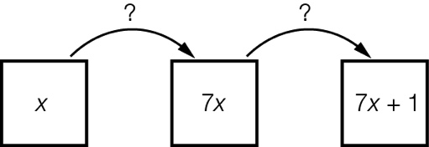

(b) ______ ______

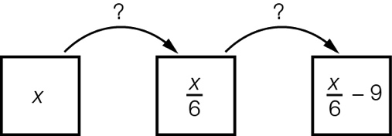

Question 20 2 marks [7.3]

The following flowchart represents an equation.

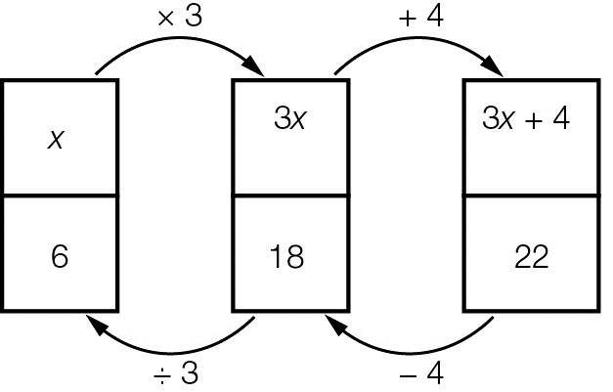

(a) What is the equation to be solved? __________ + __________ = __________

(b) What is the solution to the equation? _________

Question 21 4 marks [7.3]

Use backtracking to solve each of the following equations.

(a) 

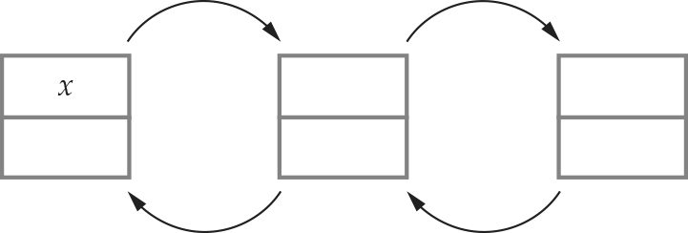

(b) 



Question 22 2 marks [7.4]

This set of scales is balanced. The left-hand side has 7 apples and 1 pineapple and the right-hand side  
has 2 pineapples and 3 apples.

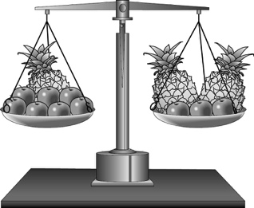

(a) If three apples are taken from the left hand side, the scales become unbalanced. Which side is now heavier?

(b) How can the scales be balanced without putting the apples back onto the scales?

Question 23 4 marks [7.4]

Solve each of the following equations using the balance method.

(a) 4x + 8 = 40

(b) 

Short answer total:________/35

Extended answer section

Question 24 4 marks [7.5]

Andrea has $410 to spend on three shirts. After buying them, she still had $56 left over. Each shirt cost the same amount.

(a) Write an equation that shows this situation. Let s represent the cost of one shirt.

(b) How much did each shirt cost?

Question 25 4 marks [7.5]

Benny and Michael have $85 between them. Benny has four times as much as Michael.

(a) Let x represent the amount of money Michael has. Write an equation for this situation.

_______________ + _______________ = 85

(b) Solve the equation.

(c) Write the amount that each of them has.

Question 26 3 marks [7.5]

Aaron bought a drink and a sandwich for $9. The drink cost $2.70. If c represents the cost of the sandwich, form an equation and solve it to find the value of c.

Extended answer total:_________/11

TOTAL test marks: _______ / 56